Practical - 8

Practical Title: MySQL Schema Design, ER Model, PDO Connectivity, and Prepared Statements

Problem Definition:
Design the database for StudentHub with students, events and
registrations. Create PHP database connection using MYSQL statements.

Theory:
1. Is the schema normalized properly?
Yes, the database schema is normalized by separating students, events, and registrations into different tables. This reduces data duplication and maintains data consistency.
2. Are primary keys and foreign keys correctly defined?
Yes, each table has a primary key to uniquely identify records. Foreign keys are used in the registrations table to link students and events, maintaining referential integrity.
3. Is the database connection handled securely?
Yes, the database connection is handled securely using PHP PDO. Prepared statements are used to execute SQL queries safely and help prevent SQL injection. Database credentials are kept in a separate configuration file.

- Implementation/ Output/Result
https://github.com/margiruparel2907-collab/webdev/tree/master/Prac_8
- Evidence of Work (Screenshots)
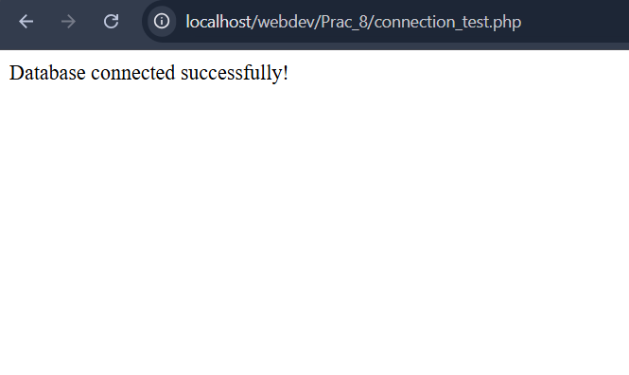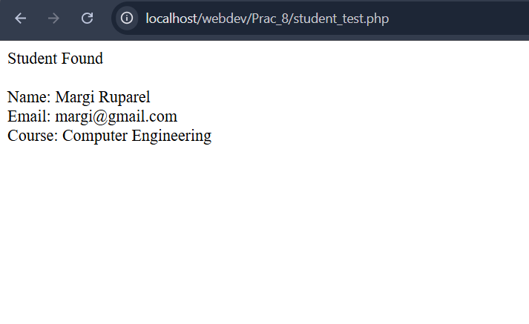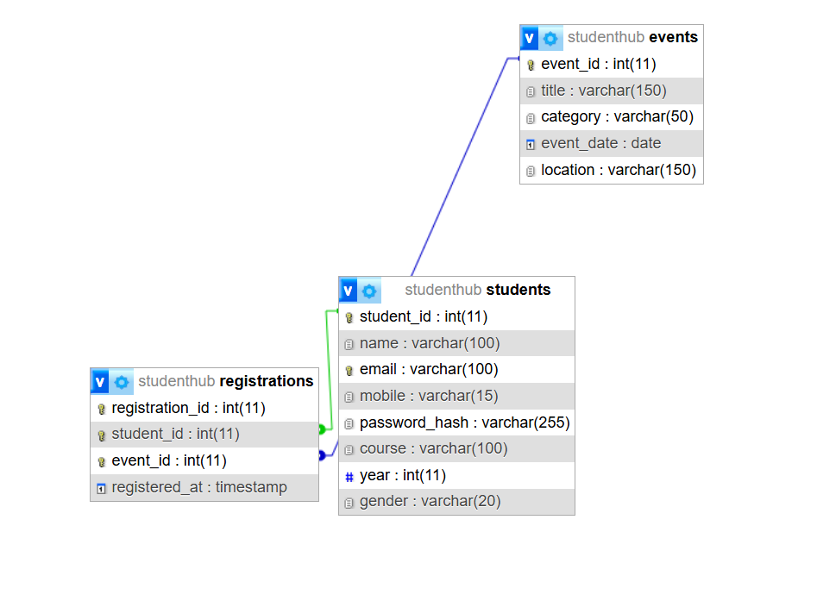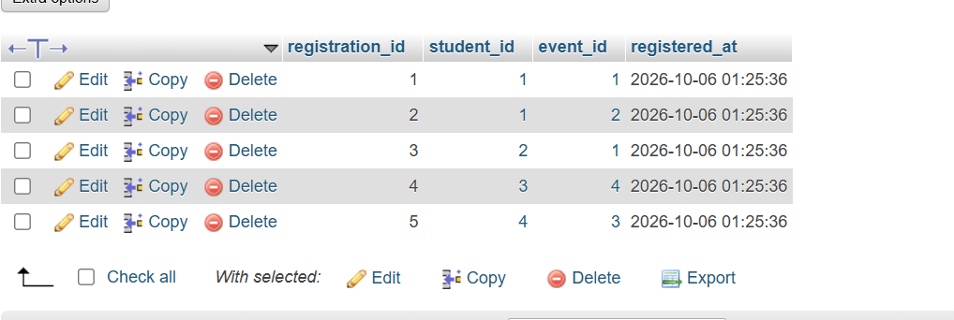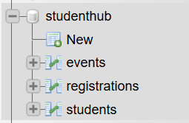
- GitHub Repository Link:
https://github.com/margiruparel2907-collab/webdev

- Challenges Faced:
During this practical, I faced challenges in designing a normalized database schema, creating relationships between students, events, and registrations, and defining primary and foreign keys correctly. I also learned to establish a PHP connection with MySQL using PDO and handle database errors properly.
- Learning Outcomes:
Through this practical, I learned how to design an ER model, create a normalized MySQL database, and establish relationships using primary and foreign keys. I also understood how to connect PHP with MySQL using PDO, execute queries with prepared statements, and improve database security by preventing SQL injection.

Faculty Remarks: (Keep this blank for faculty)

